Install SonarCube in Linux using wsl:

* sudo wget <https://binaries.sonarsource.com/Distribution/sonarqube/sonarqube-25.5.0.107428.zip>
* unzip sonarqube-25.5.0.107428.zip
* move to the required directory
* cd sonarqube-25.5.0.107428/bin/linux-x86-64
* sudo ./sonar.sh start

Start the Jenkins

* sudo systemctl start Jenkins
* goto>manage Jenkins> download >SonarCube Scanner for Jenkins
* setup in global tool configuration

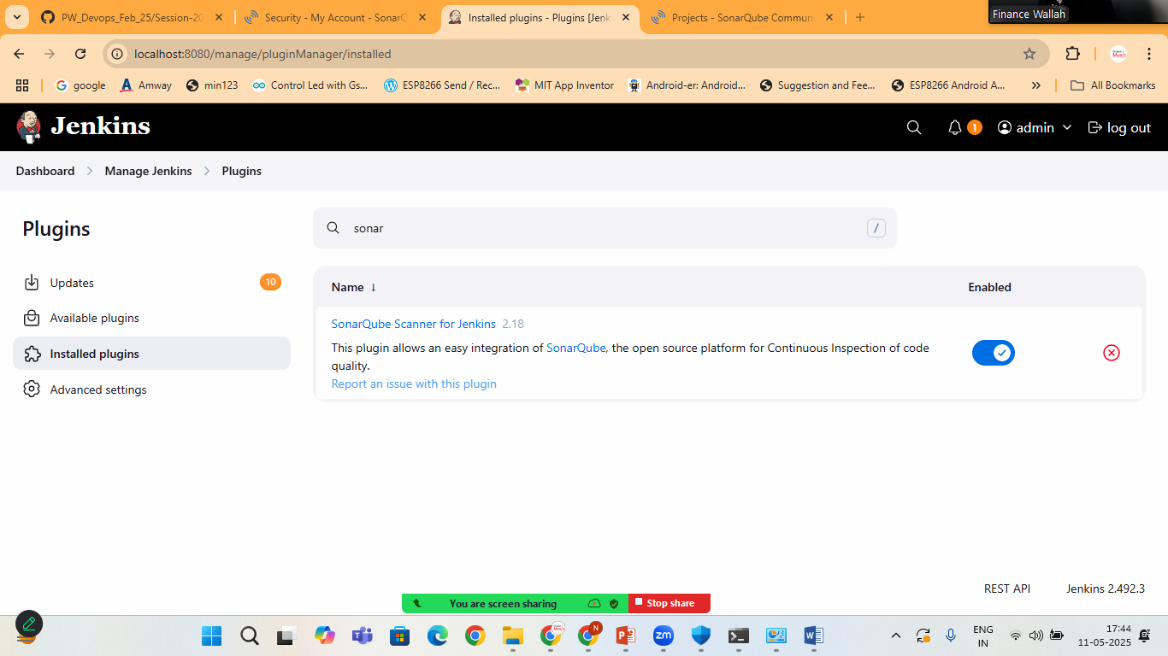

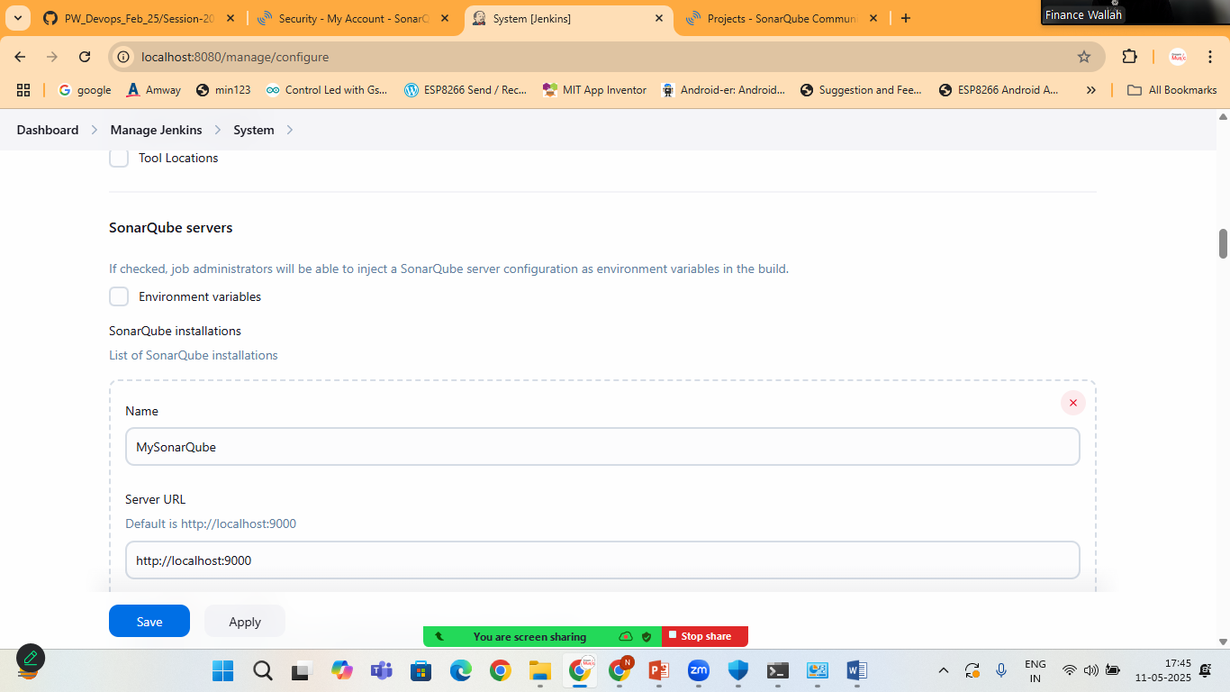

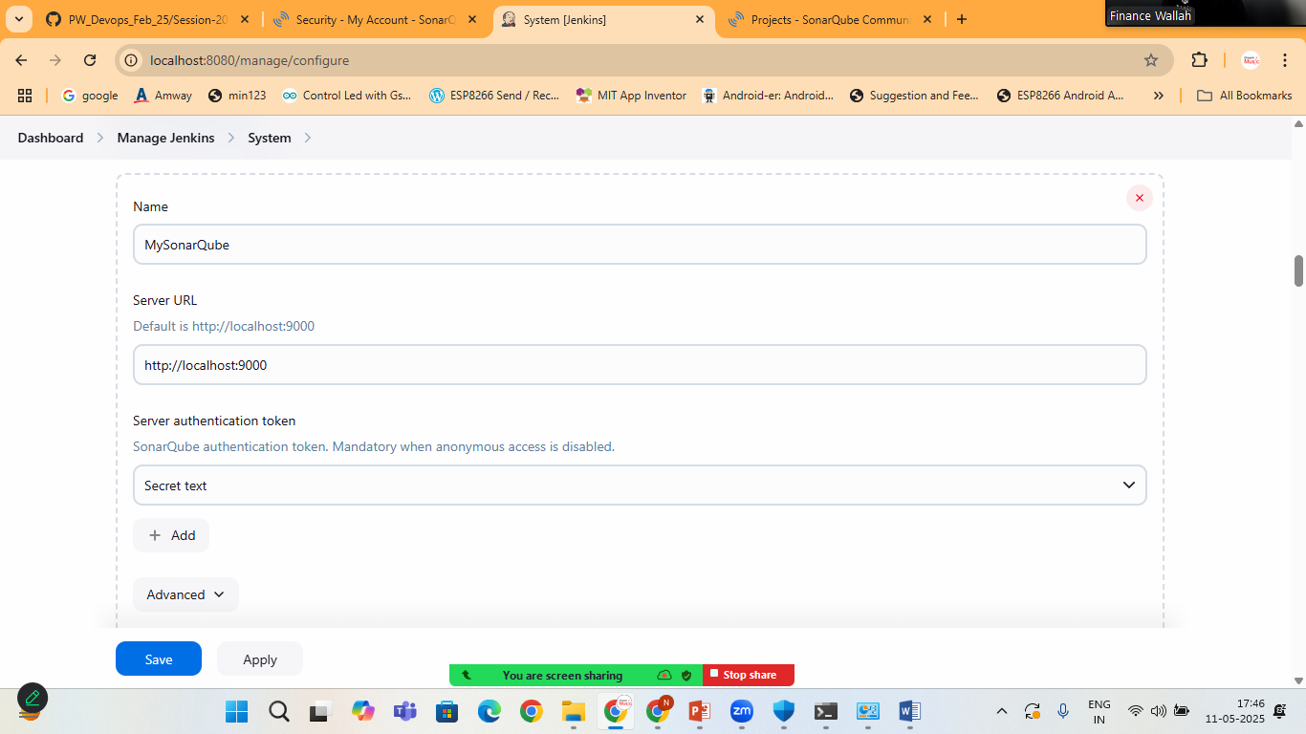

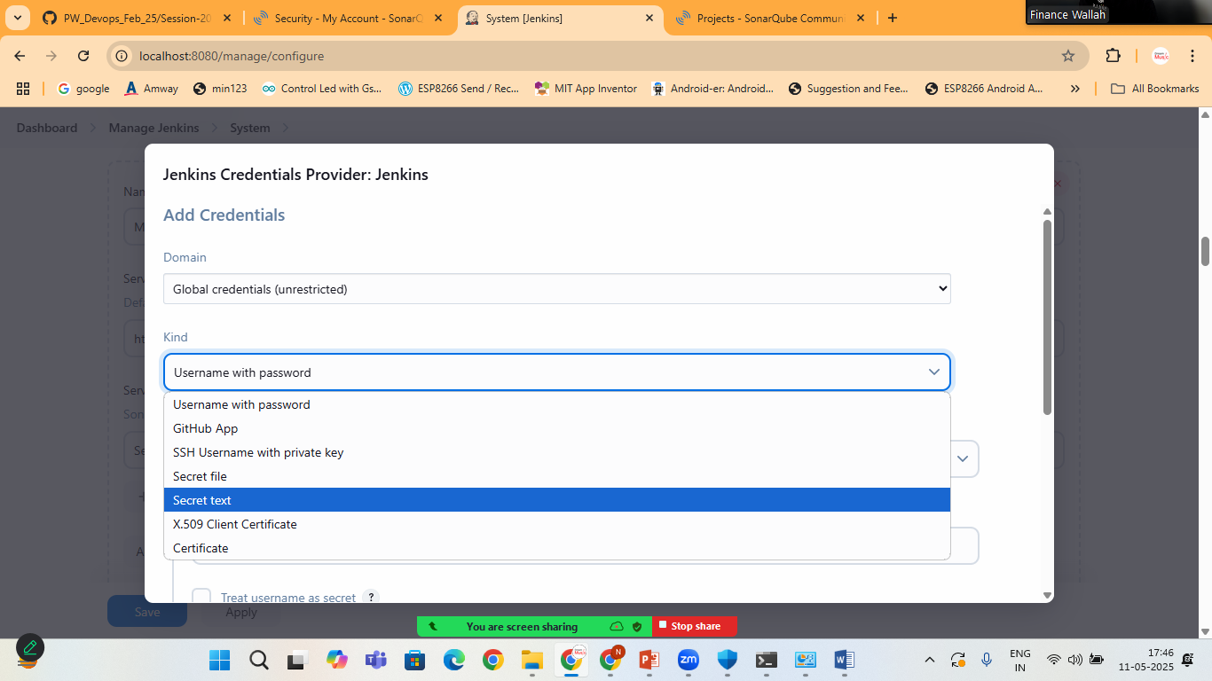

Add your token here from sonarcube

